Mathematics: Specialist
Formula sheet Units 3C and 3D

Vectors

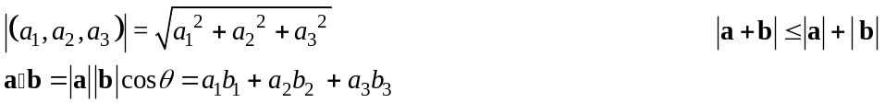
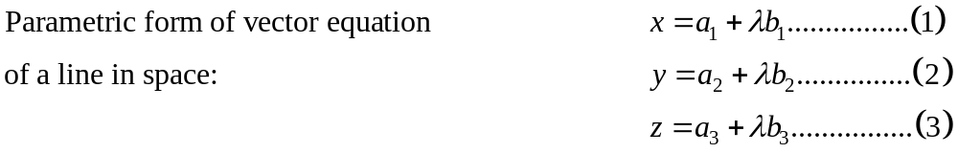

Trigonometry

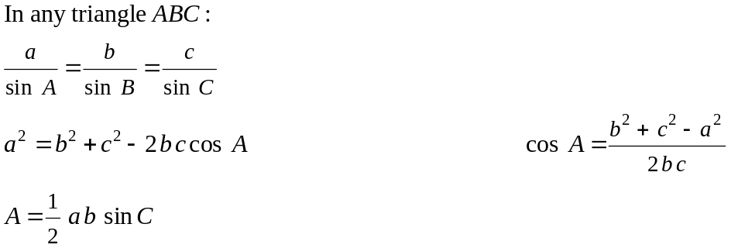
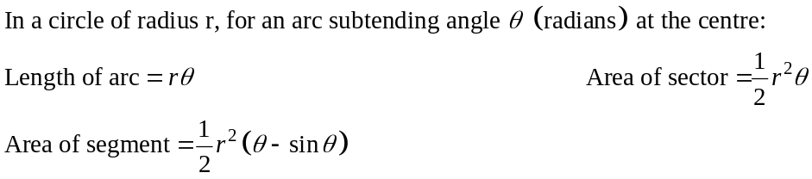
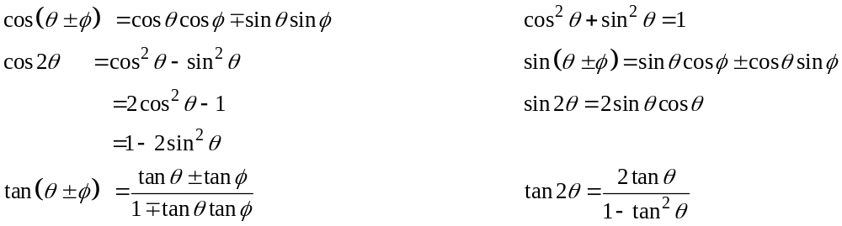

Exponentials and logarithms

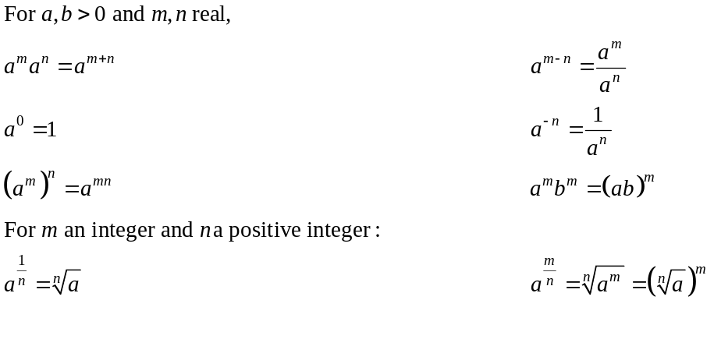
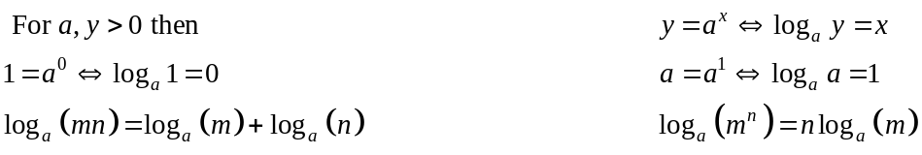
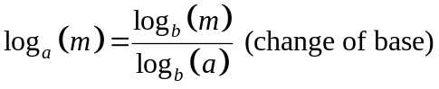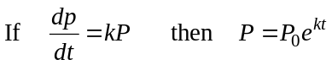

Functions

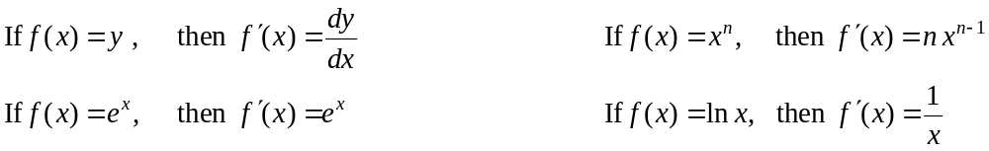

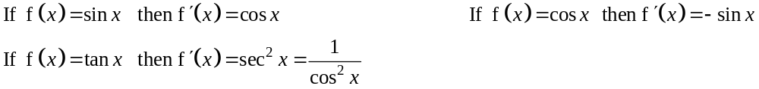

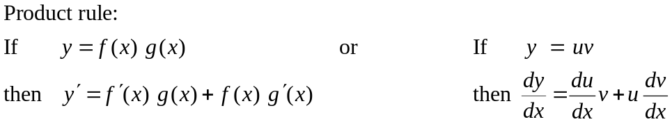

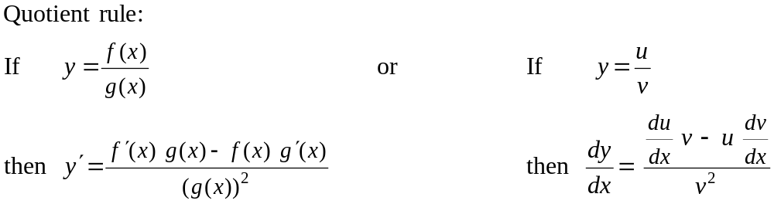
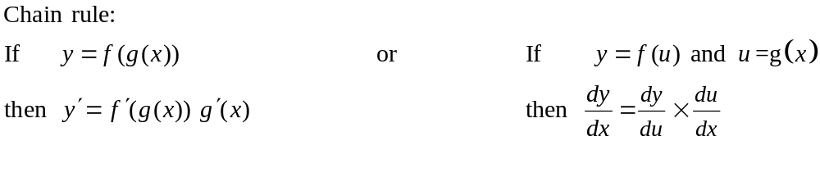
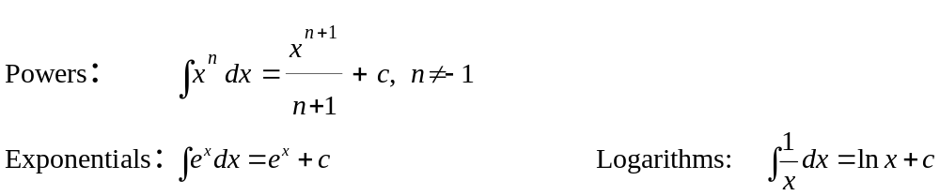
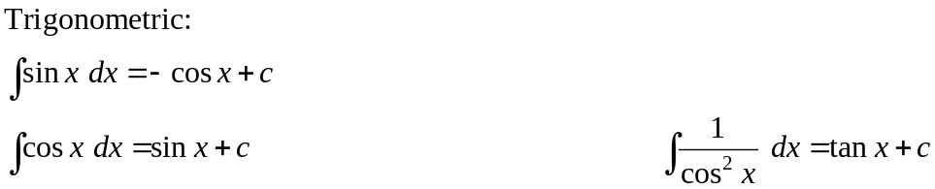
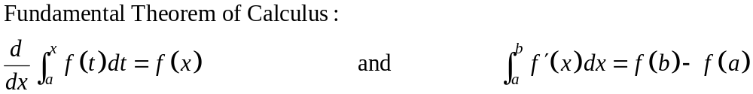

Complex numbers

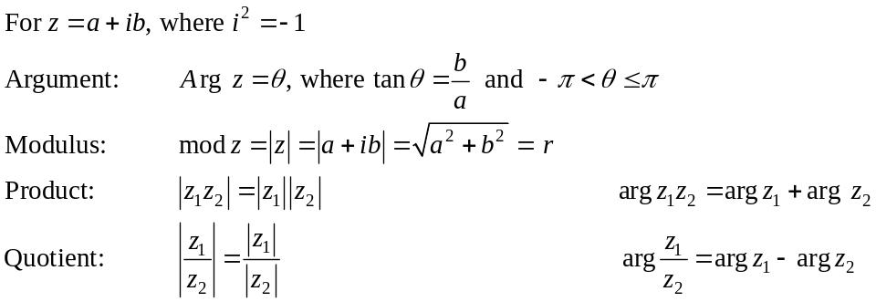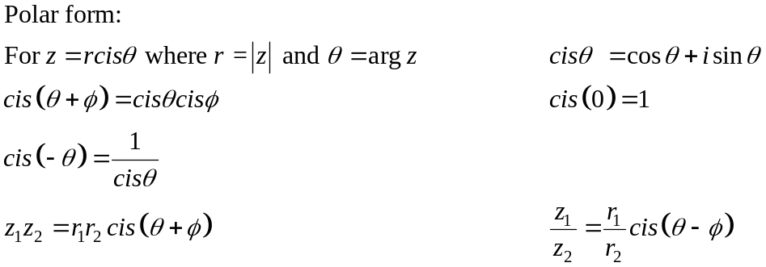
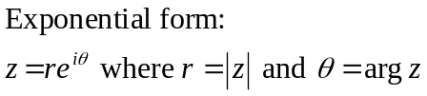
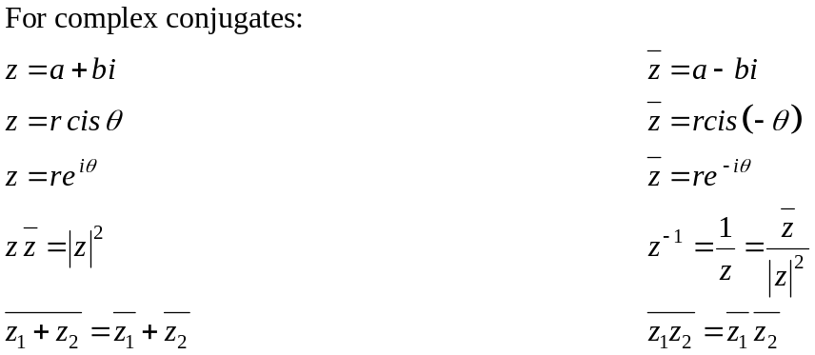

Mathematical reasoning

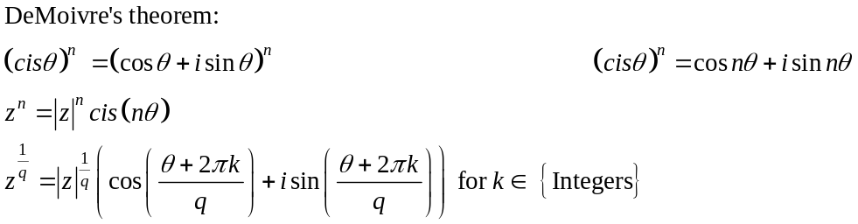

Matrices

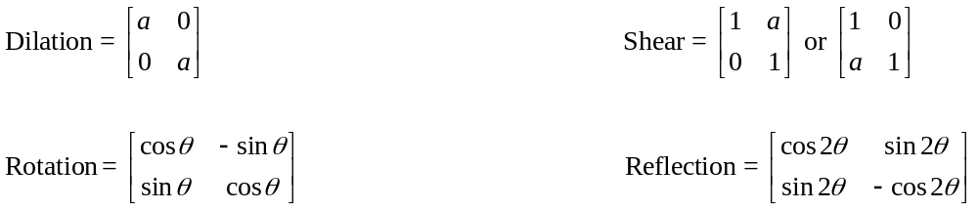

Measurement

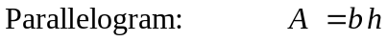
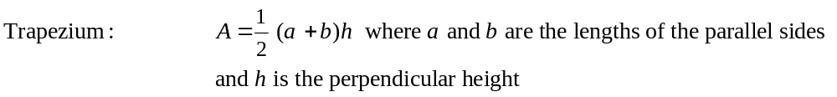
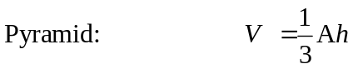
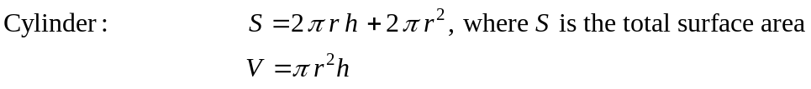
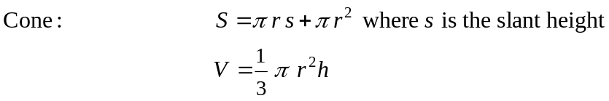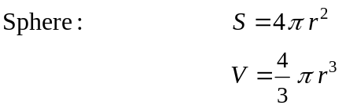

Note: Any additional formulas identified by the examination panel as necessary will be included in the body of the particular question.

